eConsult enables NHS based GP practices to offer online consultations to their patients. This allows patients to submit their symptoms or requests to their own GP electronically, and offers NHS self-help information, signposting to services, and a symptom checker.
eConsult is the most widely used digital triage tool in NHS primary care, built by NHS GPs for NHS patients, designed to enhance patient access, improve practice efficiencies and signpost patients to the right place at the right time for their care. Live in over 3013 NHS practices, eConsult gives millions of patients access to their own GP online.
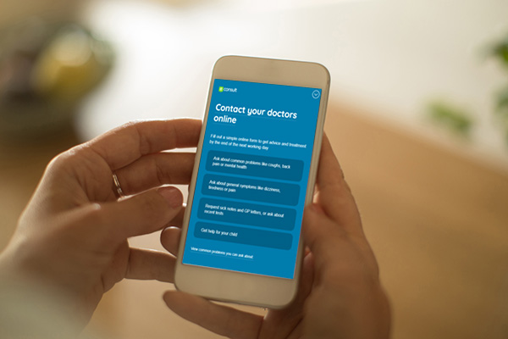

How does eConsult work?

eConsult is easy for patients and practices
eConsult lets you consult with your NHS GP online by completing a quick form that is sent and reviewed by the practice. You can also be directed to patient self-help, pharmacy advice and local self-referral services.

Benefits

You'll wonder how you did without it
- Patients may not need a trip to the surgery and their query may be resolved with a phone call
- There is no need to change surgery to get digital first access. Patients complete an online GP consultation with their own practice when they need to
- Medical advice is available 24/7 even when the practice is closed – Patients can check their health symptoms online and receive on the spot medical advice and treatment guidance thanks to NHS content
- Patients will get a response from their own NHS GP practice by the end of the next working day or sooner
- Access wherever and whenever patients want from any device. Unlike a telephone call patients can complete an eConsult at a pace that suits them, without taking up practice time
- Patients can request sick notes and test results without the need for an appointment saving patient and practice time

